Highland Alcohol and Drugs Partnership (HADP)

Drug Briefing: Alprazolam (Xanax) January 2019

Alprazolam is a benzodiazepine and is a class C controlled drug. It is not prescribed by the NHS but its availability is increased through illegal supply via online sources.

Across the UK the drug is being used either as a comedown aid from stimulants or psychedelics or to enhance dissociative effects of some drugs.

Appearance: Alprazolam is most commonly seen in 1mg tablet form and 2mg bars more commonly known as Xanax but is also available in powder form which can be mixed with other substances.

Strength: Alprazolam is 20 times the potency of Diazepam and approximately twice as potent as Etizolam. Xanax tablets are active from 0.25mg (meaning 8 doses in a 2mg bar) so people consuming full tablets are taking a very large dose. If larger amounts of Xanax is consumed this can increase the risk of overdose especially if mixed with alcohol and other drugs.

Cost: Across the UK street prices are estimated at £1.50 for 1mg and £3-5 for a 2mg Xanax bar, but this can vary and the more tablets purchased the cheaper the price.

Effects: Reported effects of pleasure, relaxation and bodily comfort, disinhibition and reduction in anxiety. Other effects may include:

- drowsiness, feeling tired;
- slurred speech, lack of balance or coordination;
- memory problems; or
- feeling anxious early in the morning.

After effects include increase in hostility and aggression. This is not a complete list of side effects and others may occur.

Harm reduction advice for individuals:

- Wherever possible, do not use on your own

- Alprazolam is 20 times the potency of diazepam. Try a small test amount (e.g. 0.25mg) and wait at least 1 hour before taking any more.

- Injecting crushed tablets in a solution is very dangerous as the tablets contain high amounts of filler which can lead to collapsed veins and cause serious vascular and tissue damage.
- It is best not to take Alprazolam on a regular basis and for more than 4 weeks due to the tolerance and dependence that can develop.

- If you have been using on a regular basis Alprazolam should not be stopped suddenly. Always reduce use gradually with your doctor’s supervision.

- The risk of overdose is much higher when Alprazolam is taken together with alcohol, opioids or any other depressant drugs.

- Naloxone will not reverse the effects of benzodiazepine drugs like Alprazolam, but it will reverse the effects of any opioid drugs that have also been taken. If unsure what has been taken Naloxone should still be administered. Dial 999 and ask for an ambulance.

If someone is feeling unwell following consumption of Xanax tablets or Alprazolam in any other form, medical attention should be sought immediately. If someone is unresponsive or experiencing symptoms causing concern dial 999 and ask for an ambulance.

If you are concerned about your own drug use or that of someone else, support services are available across your region here. Please visit www.highland-adp.org.uk or phone the Osprey House on 01463 716888 or Highland Alcohol and Drug Advice Support Service
(HADASS) on (01463) 717594
.

Examples of Xanax tablets:

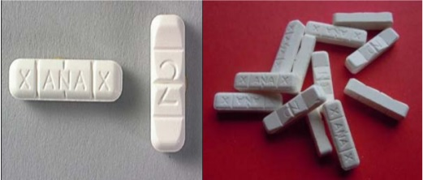

More detailed information on Alprazolam is available here.

Visit the The Drugs Wheel's DrugWatch page to find detailed information on other drugs and harm reduction.

